

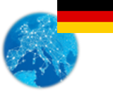 **Germany** *Energy Union factsheet[1]*

1. **Macro-economic implications of energy activities**

Energy and transport are key sectors for the overall functioning of the economy as they provide an important input and service to the other sectors of the economy. Together, the activities in these two sectors[2] accounted for about 6.3% of the total value added of Germany in 2015. Similarly, their share in total employment was 5.5% of total employment[3] in 2015, of which 4.9% in the transport sector and 0.6% in the energy sector.

The decarbonisation of the energy and transport sectors will require significant investments and economic activity beyond the remit of these sectors themselves. The energy transition implies a structural shift in economic activity. Energy-related investment and jobs will in part migrate from traditional fossil fuel based activities towards construction, equipment manufacturing and other services related to the deployment of low carbon and clean energy technologies. At the moment, the efforts related to the low-carbon and clean energy transition in sectors beyond energy can only be partially quantified and are therefore not included in this analysis.

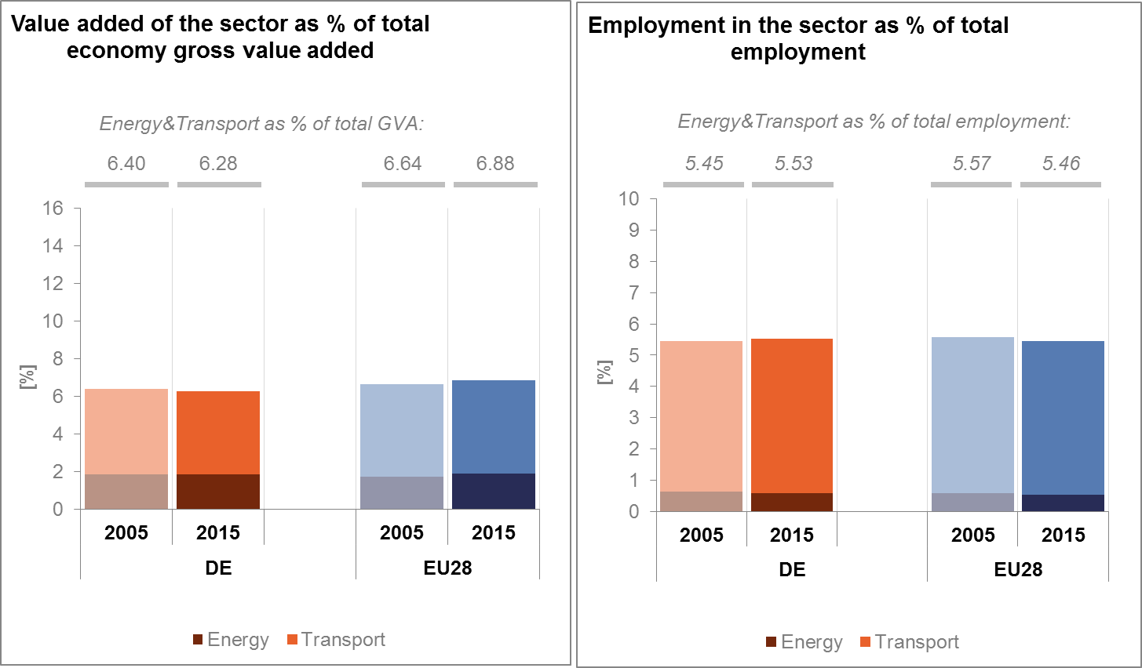

*(Source: Eurostat)*

In the case of renewable energy, both the direct as well as the indirect effects on employment are being estimated. According to EurObserv'ER, in 2015, the share of renewable energy related employment in total employment was at about 0.84% in Germany, well above the EU average of 0.54%. Employment is particularly high in wind, biomass and biogas industries but it is also significant in solar photovoltaic, biofuels and heat pumps industries. The turnover of the renewable energy industry was estimated at around EUR 29.6 billion. About 40% are attributed to the wind industry, 23.5% to biomass industry and more than 10% to the photovoltaic industry.

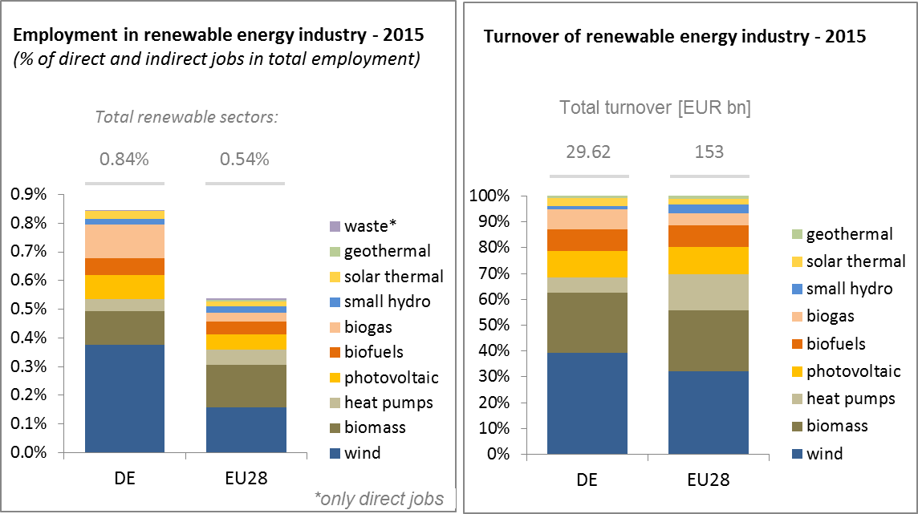

*(Source: EC based on EurObserv'Er and Eurostat)*

An indication of the level of undertaken efforts in the German energy sector is provided by the Gross fixed capital formation (GFCF)[4]. Investments in the electricity and gas sectors, serving as reference sectors, have been relatively stable since 2008 at around 0.4%–0.5% of the country's GDP. However, these figures do not include the rising investment in renewable energies. Therefore, the shares may underestimate the actual investment in the energy sector as share of German GDP.

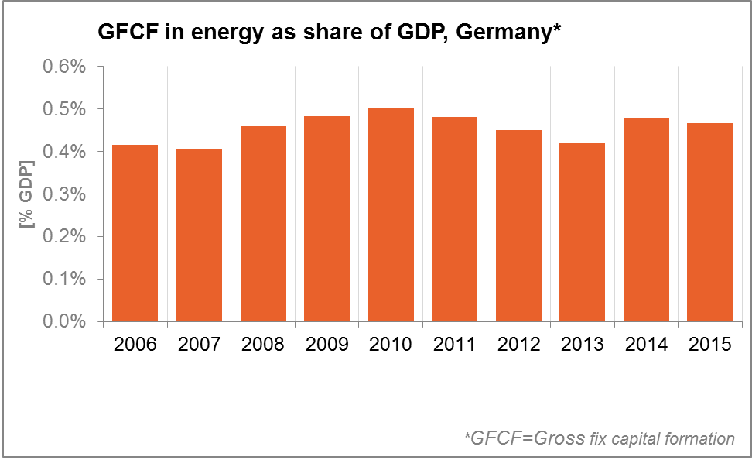

*(Source: Eurostat)*

In terms of trade balance, Germany is a net importer of fossil fuels and a net exporter of electricity. The trade deficit in energy products decreased from about 2.7% of GDP in 2006 to 1.9% in 2015, influenced by improvements in energy efficiency, an increase of domestic renewable energy sources and by the decrease in prices of energy commodities. The largest decrease is accounted for by petroleum products. The trade deficit for gas is on a decreasing trend after a peak in 2011/2012. It amounted to 0.65% of GDP in 2015, which was similar to the level in 2005.

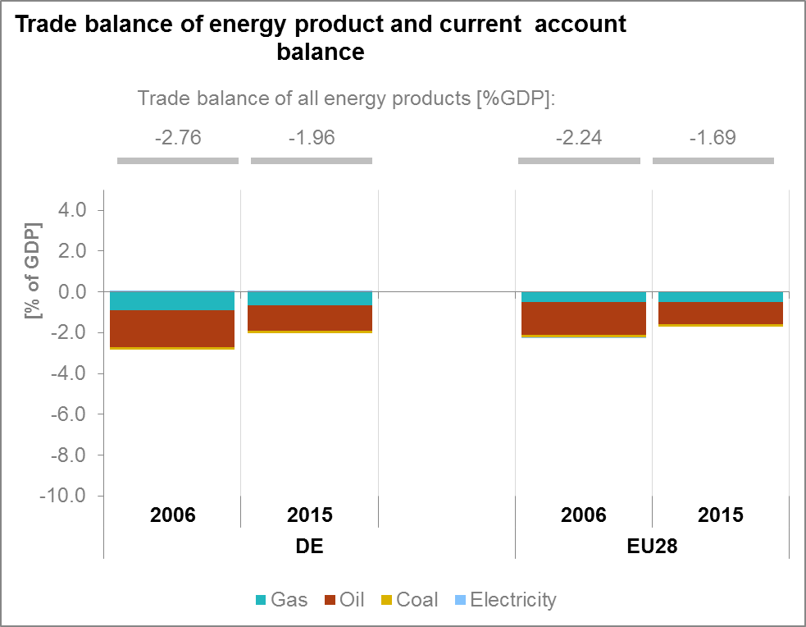

*(Source: Eurostat)*

1. **Energy security, solidarity and trust**
   1. **Energy Mix**

In comparison to the average energy mix in the European Union, Germany's (DE) energy mix has a similar share of renewable energy (12% DE; 13% EU), of natural gas (20.5% DE; 22.0% EU) and of oil (33.7% DE; 34.4% EU). Solid fuels have a higher share in Germany (25.0% DE; 16.2% EU) partly due to domestic lignite reserves. Nuclear energy accounts for a lower share (7.4% DE; 13.6% EU) in the German energy mix, reflecting the nuclear phase out in Germany.

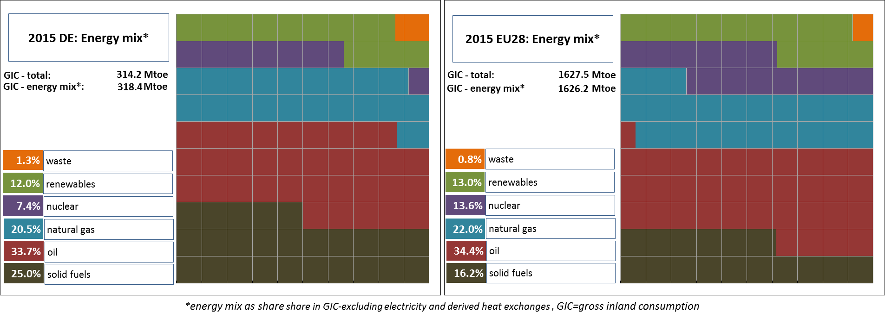

*(Source: Eurostat)*

* 1. **Import dependency and security of supply**

61.9% of German energy consumption relies on imports, a value slightly higher than the EU average. There was an increase of about 1.5 percentage points (p.p.) in overall import dependency in Germany between 2005 and 2015, whilst also at the EU level, import dependency increased by 1.9p.p. over the same period. In 2015, Germany imported more than 90% of its natural gas, almost all of its oil needs, and approx. 88% of its hard coal which represents a considerable increase compared to 2005.

Russia accounted for 42.6% of natural gas imports in Germany. Russia is also the dominant non-EU supplier of crude oil (35.7%) and hard coal (27.0%) to Germany. In the areas of natural gas and crude oil, Russia is followed by Norway (21.5% for natural gas; 13.6% for crude oil).

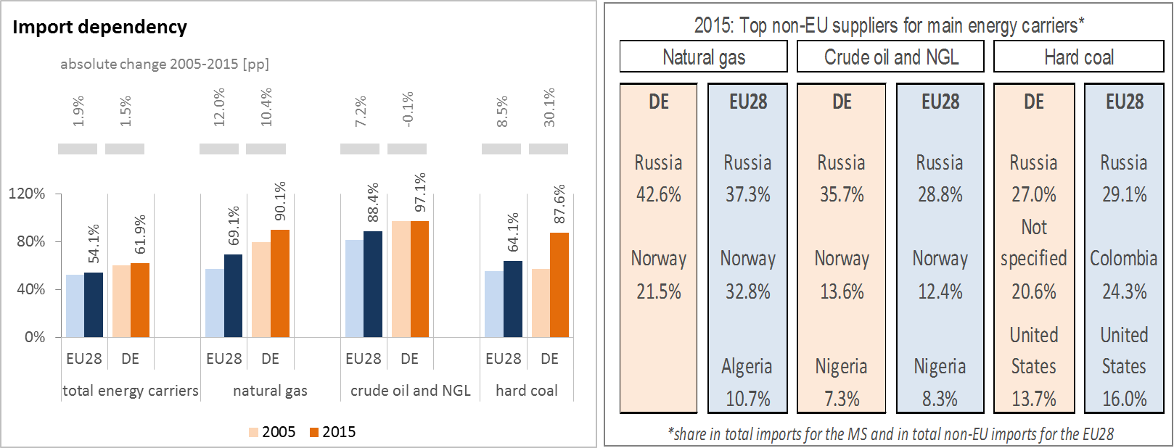

*(Source: Eurostat)*

The Regulation concerning measures to safeguard security of gas supply requires that if the single largest gas infrastructure fails in one Member State, the capacity of the remaining infrastructure has to be able to satisfy total gas demand during a day of exceptionally high gas demand. Germany complies with this rule.

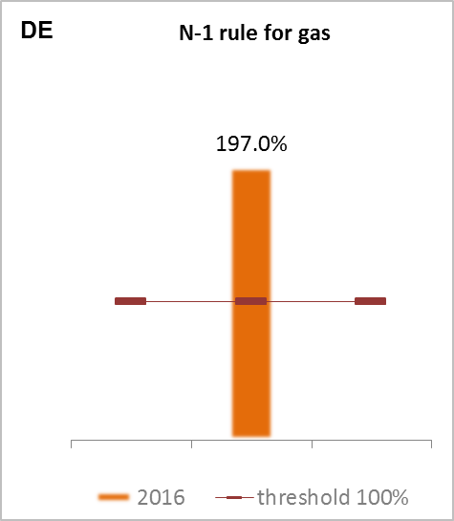

*(Source: gas coordination group)*

1. **Internal market**
   1. **Interconnections and wholesale market functioning**
      1. **Electricity**

|  |  |
| --- | --- |
|  | |
| *(Source: EC based on ENTSO-E scenario outlook and adequacy forecast 2014)* | *(Sources: EC services based on Eurostat for the left graph and based on Platts and European power exchanges for the right graph)* |

Between 2014 and 2017, the electricity interconnection level[5] of Germany decreased from 10% to 8.9% and hence is behind the 2020 target of 10%. Nevertheless, the country is on the path to reach the 10% target by 2020 through the completion of PCIs currently under way.

The concentration of the power generation market is much below EU average in Germany. Also wholesale electricity prices are well below the EU average. A decrease higher than EU average (ca. 16% DE; ca. 11% EU) was recorded between 2013 and 2015. This reflects a high level of competition at the wholesale level, though not always translated down to lower retail prices.

Internal congestion in the German electricity transmission network remains a challenge both inside Germany and in neighbouring Member States. Considerable effort is made to improve internal networks, but delays in important projects are significant, in part due to political resistance. Network congestion requires increasing interventions by transmission system operators. Additionally, a system of reserve has been introduced to temporarily address the internal congestion until the internal network is sufficiently developed.

There are new requirements for the German grid, also in the light of renewable electricity generation. Renewable electricity is produced and owned in a decentralised way. Major offshore projects planned in the North Sea and Baltic Sea are expected to increase the need for grid management.

Occasional grid congestion arises for several reasons, such as the simultaneous feed-in of conventional plants and high feed-in of renewable electricity (which leads to renewable generation feeding in the transmission grid and not the distribution grid) or, on the consumer side, congestion due to sharp load increase.

The recent agreement with German authorities on the introduction of capacity allocation at the border to Austria can provide clarity for the interim period, until coordinated regional capacity calculation within a European legal framework is finalised. However, bilateral agreements cannot replace the need for a coordinated regional process based on technical power system constraints and involving competent regulatory authorities of all affected Member States.

* + 1. **Gas**

Wholesale gas prices remain slightly below average EU gas prices. The market concentration for wholesale gas supply is lower than for the EU average. However, from 2011 to 2015, market concentration increased significantly (+76.8%).

Domestic gas production has continuously declined in recent years (from 600 PJ in 2005 to 265 PJ in 2015).

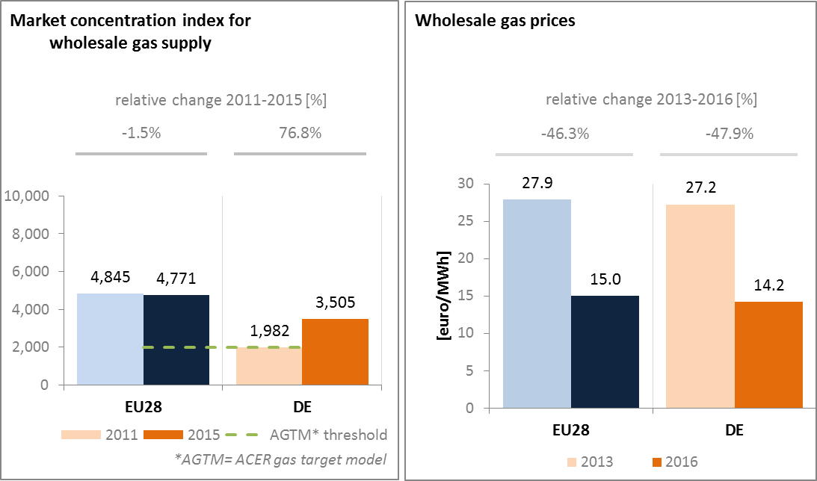

*(Source: ACER for the left graph and EC services based on Platts, gas hubs, Eurostat for the right graph)*

* 1. **Retail electricity and gas markets for residential consumers**

Germany was one of the most competitive gas markets for household consumers in 2015. The relative level of competition improved in Germany between 2014 and 2015 on the gas and electricity markets.

* + 1. **Electricity**

In 2016, households' electricity prices in Germany were higher than the EU average. This can partially be explained by a comparably higher share of taxes and levies in Germany compared to the EU average. Between 2013 and 2016, average band retail electricity prices for households only increased to a very low extent. However, falling wholesale prices for electricity did merely affect retail electricity prices for households.

There is no widespread deployment of smart meters, but there is a relatively high annual switching rate by consumers from one electricity supplier to another due to a well-functioning retail market.

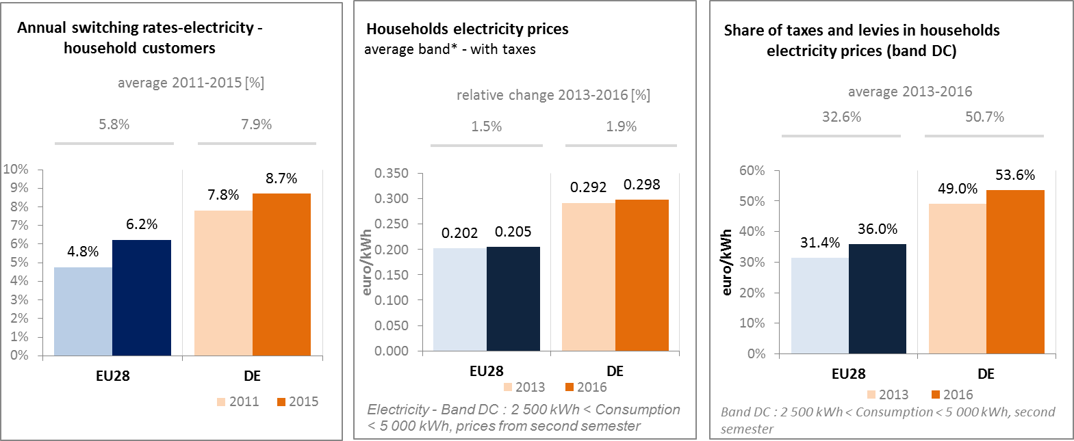

*(Source: ACER) (Source: Eurostat) (Source: Eurostat)*

* + 1. **Gas**

Household gas prices in 2016 in Germany were at EU average. The share of taxes and levies on gas is approximately at EU average and is significantly lower than the share of taxes and levies on electricity. The annual switching rate is higher than the EU average and displays an increasing tendency.

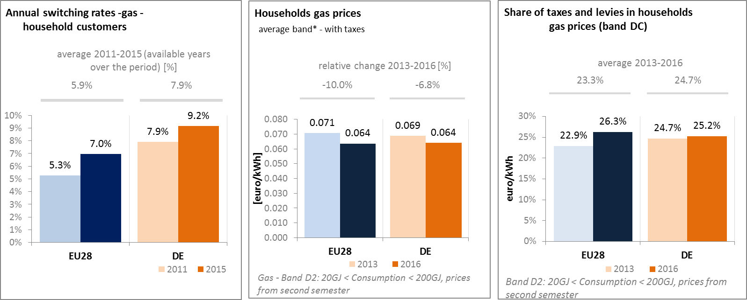

*(Source: ACER) (Source: Eurostat) (Source: Eurostat)*

* + 1. **Market performance indicators**

From 2010 until 2015, the energy market performance indicator (MPI) increased from approximately EU average to values above EU average. This indicates a good market performance both for retail gas and electricity services, according to consumers. The MPI takes into account five key aspects of consumer experience: comparability, trust, problems & detriment, expectations and choice.

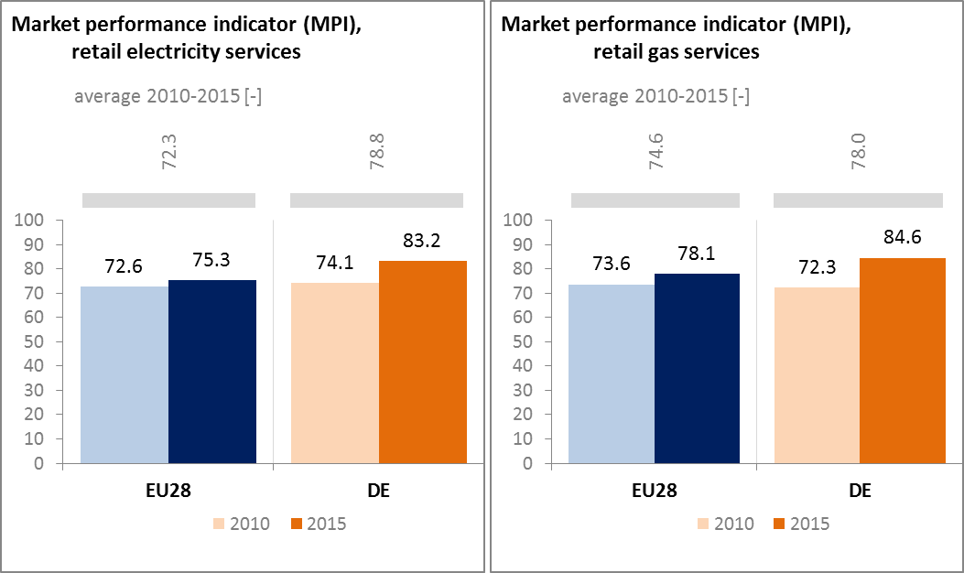

*(Source: DG JUST survey)*

* 1. **Energy affordability**

In Germany, the share of energy expenditure in total household expenditures of the lowest quintile of population is on EU-average. This share increased in Germany from 7.4% in 2004 to 8.4% in 2014. Compared to the EU average, a smaller part (up to 12.7%) of citizens below the at-risk-of poverty threshold consider that they are unable to keep their home adequately warm.

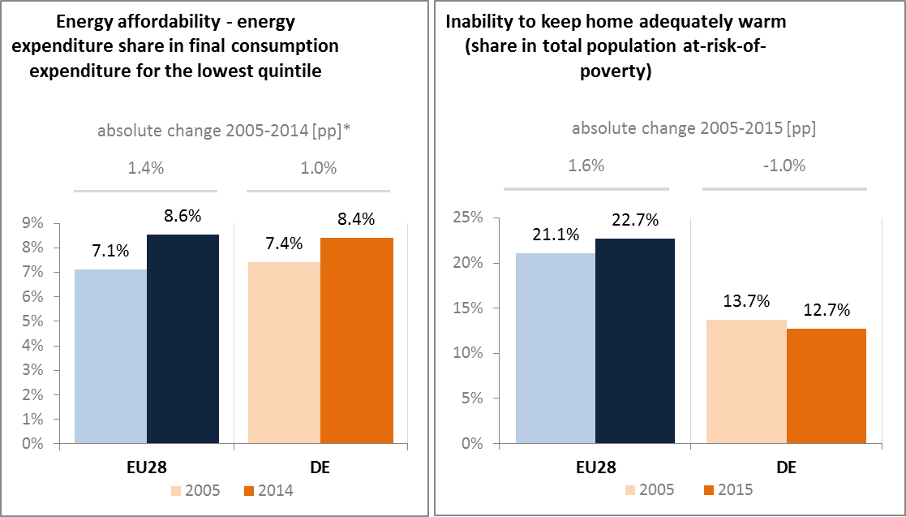

*(Source: ad-hoc data collection of DG ENER based on HBS with the support of Eurostat and national statistics)*

1. **Energy efficiency and moderation of demand**

The German Federal Government decided to implement a National Action Plan on Energy Efficiency (NAPE). The NAPE comprises 20 immediate measures; and a set of long-term work processes. The plan has three pillars:

1. *Stepping up energy efficiency in buildings.* The NAPE strengthens existing measures like the CO2 Building Modernisation Programme, administered by the German development bank KfW. This follows a long-term energy efficiency strategy for buildings aiming on pathways to achieve a climate-neutral building stock by 2050;
2. *Strengthening the market for energy efficiency services.* The NAPE strengthens public guarantees for energy performance contracting. A new competitive tendering scheme for energy efficiency measures aims at activating measures with the best cost-benefit ratio.
3. *Individual responsibility for energy efficiency.* High-quality energy consulting services are key to put consumers in a position to make informed decisions about their energy consumption. Together with 20 industry and business associations, the Federal Government aims at initiating 500 energy efficiency business networks until 2020.

Next to the NAPE, the Federal Government put together a package of financial incentives to improve the efficiency of heating systems, to support the utilisation of waste heat in the industry, as well as new energy efficiency measures at municipal level and in rail transport.

The NAPE and the German efficiency policy are reviewed on a continuous basis. For this purpose, Germany has launched the “green paper” process, aiming at establishing the “efficiency first” principle, and it has organised a wide stakeholder consultation.

Since 2005, Germany decreased its primary energy consumption by 7.7% to 293 Mtoe in 2015. Over the same period, final energy consumption decreased by 2.9% to 212 Mtoe in 2015. Germany needs to continue efforts in order to reach the 2020 national targets for energy efficiency (276.6 Mtoe in primary energy consumption and 194.3 Mtoe in final energy consumption).

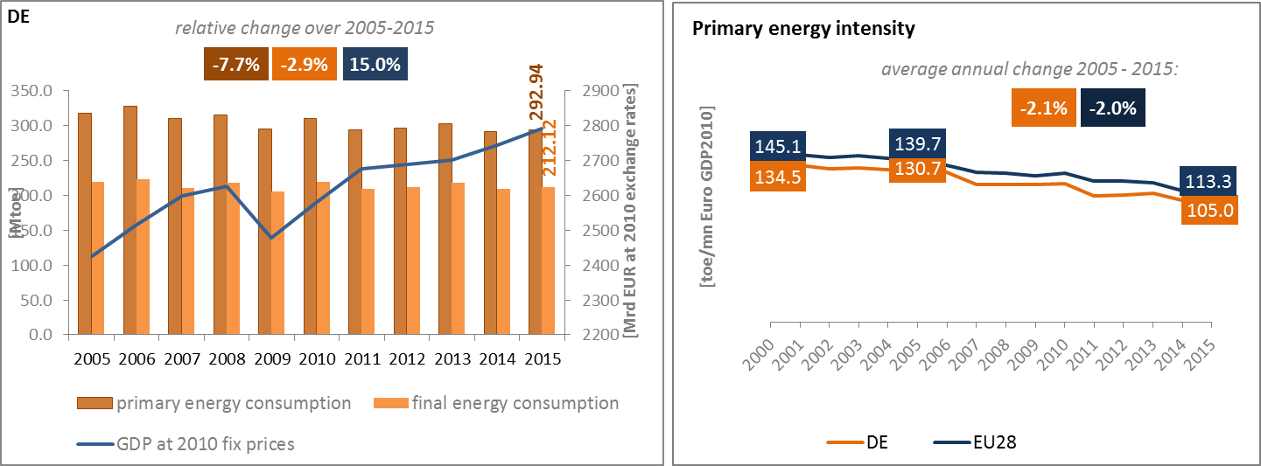*(Source: Eurostat)*

Primary energy intensity decreased over the period 2005–2015 in parallel to the EU average, while remaining slightly below EU average. A detailed sectoral assessment illustrates these trends: the energy intensity of Germany's industry is still well below EU average, but has lost some of its advance. In the services sector, the German energy intensity is higher than the EU average, while the final energy consumption of households per square meter is slightly above EU average.

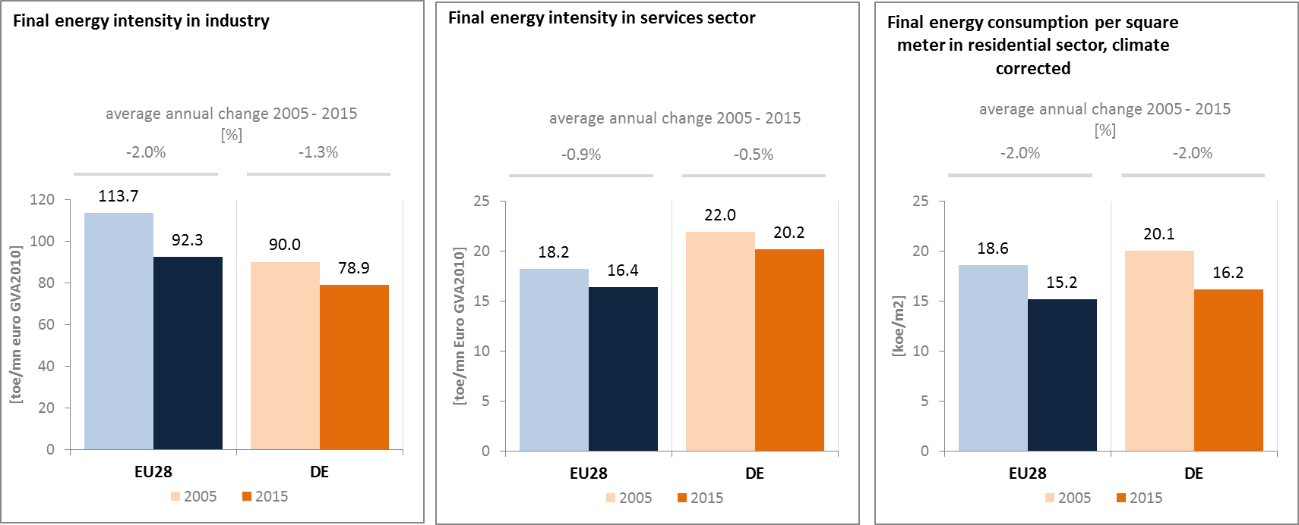

*(Source: Eurostat) (Source: Eurostat) (Source: Odyssee database)*

In 2015, the transport, industry and the residential sector each accounted for 25% to 30% of total final energy consumption, which is similar to the EU average. The services sector accounts for the remaining 16.4%, slightly higher than the EU average at 13.6%.

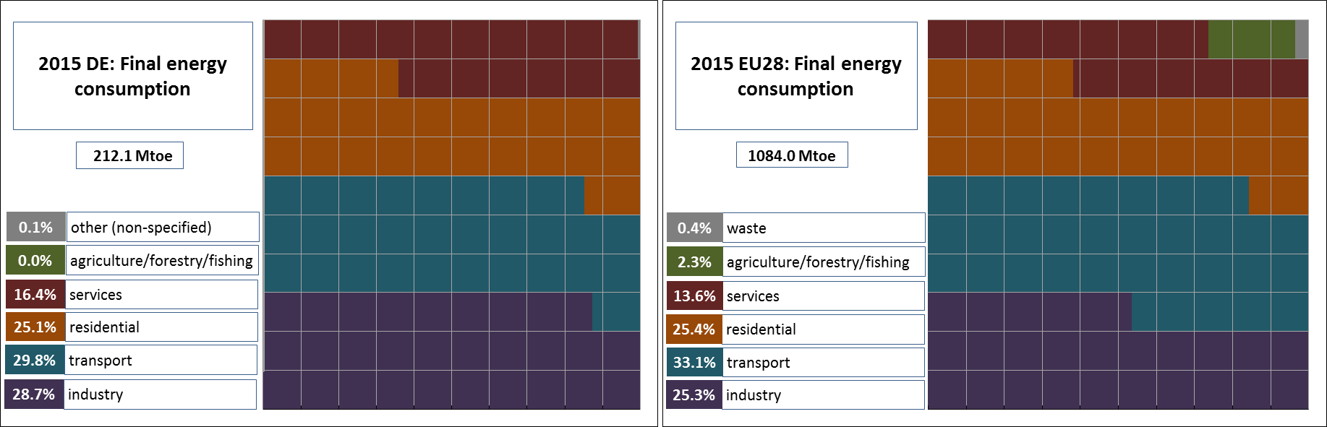

*(Source: Eurostat)*

From 2005 to 2015 in Germany, the final energy consumption in transport recorded an average annual increase of 0.1%, lower than the 1.4% average annual GDP growth. Compared to rising passengers and freight transport activity (increasing respectively by 8.4% and 13.7% with aviation excluded) during the period 2005 to 2015, the increase of energy consumption is less pronounced.

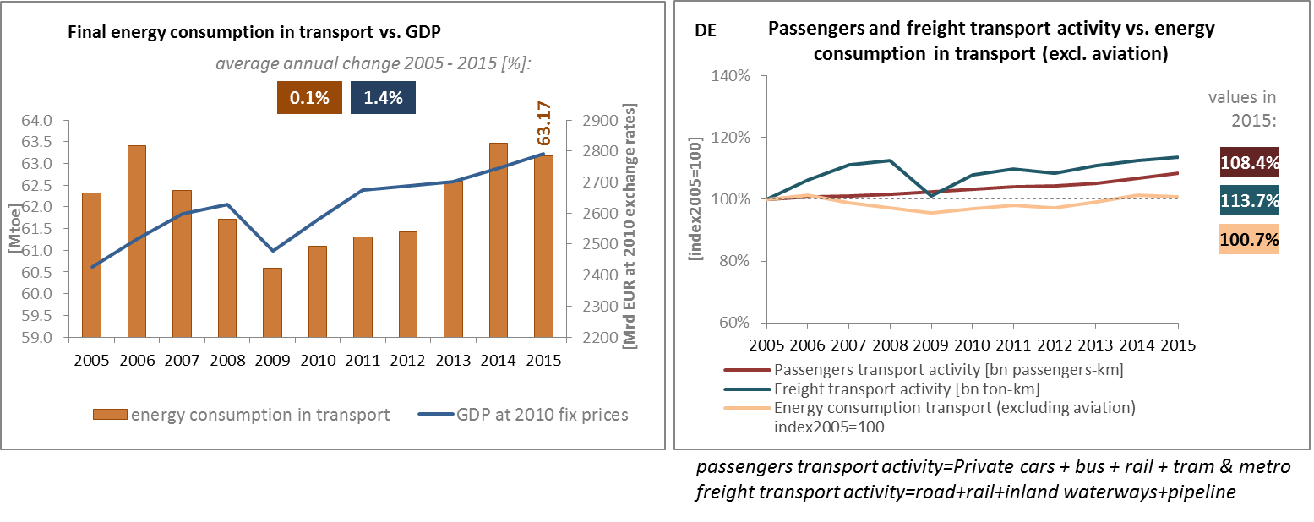

*(Source: Eurostat) (Source: Eurostat and DG MOVE pocketbook)*

Between 2005 and 2015, the share of collective transport modes in all passengers' transport has remained stable in Germany while the EU average is slightly rising.

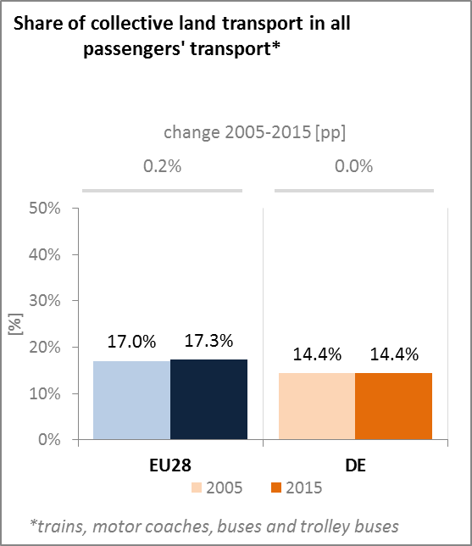

*(Source: Eurostat)*

On 3 August 2016, the German Government adopted its new federal transport infrastructure plan (Bundesverkehrswegeplan 2030) for the intended investment until 2030. The plan serves as a key planning tool and sets the framework for investments into maintenance, upgrade and new construction of road, rail and waterway infrastructure. The plan foresees investments with a volume of EUR 269.6 billion, a large increase of nearly EUR 100bn compared to its predecessor, and contains more than 1,000 projects. In contrast to earlier versions, the bulk of investments will go into maintenance and replacement of existing infrastructure rather than into new construction.

Besides the more traditional goals of ensuring passenger and freight mobility, increasing competitiveness of businesses, transport safety, emission reduction, limiting land use for transport purposes and improving living conditions in urban areas and regions (i.e. noise reduction), the plan also sets the ground for future developments in the transport sector. In this regard, it will help facilitating the digitalisation of the transport sector by laying the ground for the introduction of intelligent transport systems and connected driving in road transport or river information systems in waterway transport.

Furthermore, under the heading sustainable and secure mobility the Federal Government aims at helping to promote the electrification of the sector (using renewable energy sources) by supporting e-mobility and the build-up of the corresponding fuelling and recharging infrastructures.

1. **Decarbonisation of the economy**
   1. **GHG emissions**

In November 2016, the German Government adopted the Climate Action Plan 2050 which will also contribute to lowering the final energy consumption in transport. In 2016, GHG emissions in Germany were 26.4% below their 1990 levels, a higher decrease compared to the EU average of -22.6%. Preliminary data indicates that Germany reaches its ESD target for 2016 by a small margin. However, projections indicate that Germany will exceed its 2020 ESD target by 3.3 percentage points.

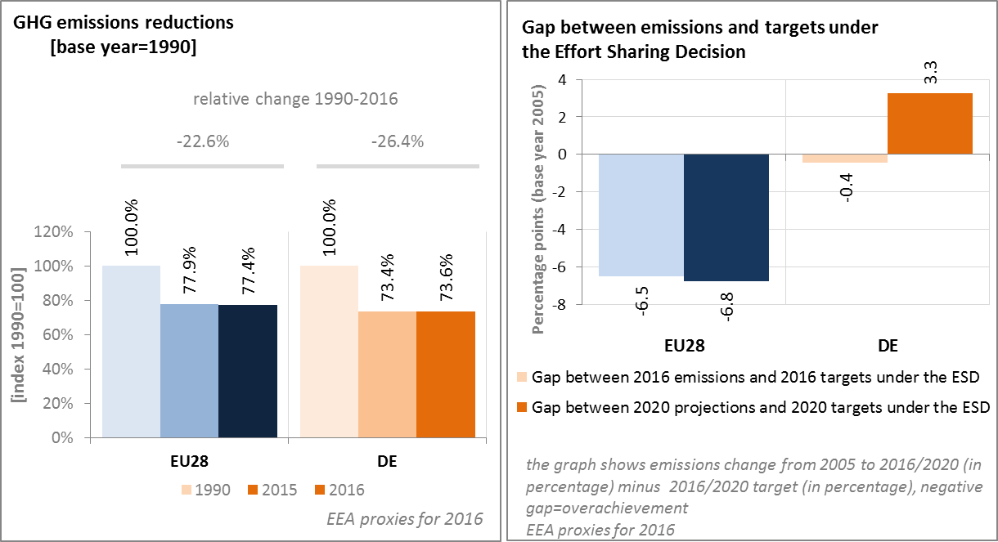

*(Source: EC and EEA)*

According to 2016 European Environment Agency (EEA) estimates, the GHG intensity of Germany's economy was slightly above the EU average, continuously decreasing since 1990. In 2016, the GHG emissions per capita in Germany were approx. 30% above the EU average, decreasing from around 33% above the EU average in 1990.

In 2015 in Germany, the largest sector in terms of GHG emissions was the energy sector (38.4% of the total GHG emissions), followed by industry (20.9%), transport (17.8%) and residential & commercial (13.4%). In relative terms, GHG emissions from energy/power industry, industry, and residential & commercial sectors of Germany were above EU average (i.e. 38.4% vs 30.9%, 20.9% vs 19.9%, and 13.4% vs 12.8% respectively).

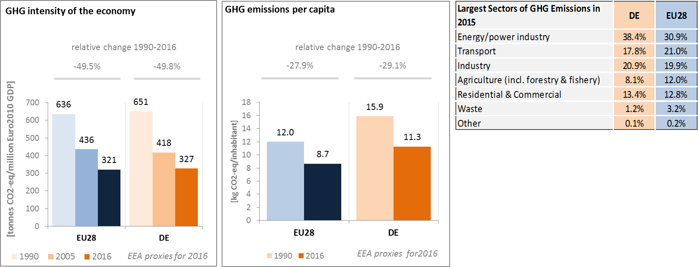

*(Source: EC and EEA)*

Preliminary accounts under the Kyoto Protocol for Germany show overall removals of -38.3 Mt CO2-eq. as an annual average in the period 2013-2015. For comparison, the annual average of the EU-28 accounted for removals of -119.0 Mt CO2-eq. It should be noted that in this preliminary simulated accounting exercise, removals from Forest Management did by far not exceed the accounting cap.

Of highest importance are removals by Forest Management, followed by removals by Afforestation. The impact of activities such as removals by Grassland Management and emissions by Deforestation and Cropland Management are comparatively small. Overall, there is a slightly increasing trend in removals due to a combination of various activities. Removals by Forest Management, Afforestation and Grassland Management increased while emissions by Deforestation and Cropland Management remained nearly constant over the course of the three-year period.

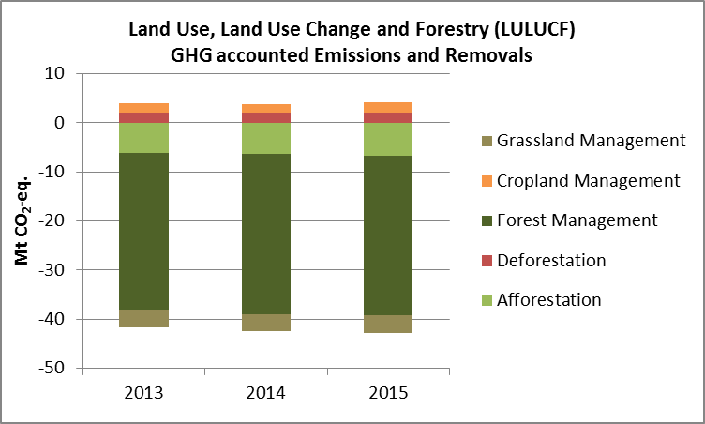

*Note: Forest Management credits are capped and presented as yearly averages when the total Forest Management credits of the considered period exceed the simulated cap over the same period.*

*(source: EC and EEA)*

**CO2 emissions in transport and alternative vehicles**

In Germany, CO2 emissions from road-based transport were almost at the same level in 2015 as in 1990, but the relative share of emissions coming from trucks and buses increased compared to emissions from cars and vans. The reduction of CO2 emissions from cars is partly due to a reduction of CO2 emissions from new passenger cars sold from 2005 onwards, at a rate similar to the EU average (i.e. 27% less from 2005 to 2016). Nevertheless, average CO2 emissions of new cars sold in Germany in 2016 were above EU average. It should be noted that these figures refer to test cycle CO2-performance (not real-world CO2-performance) of new vehicles.

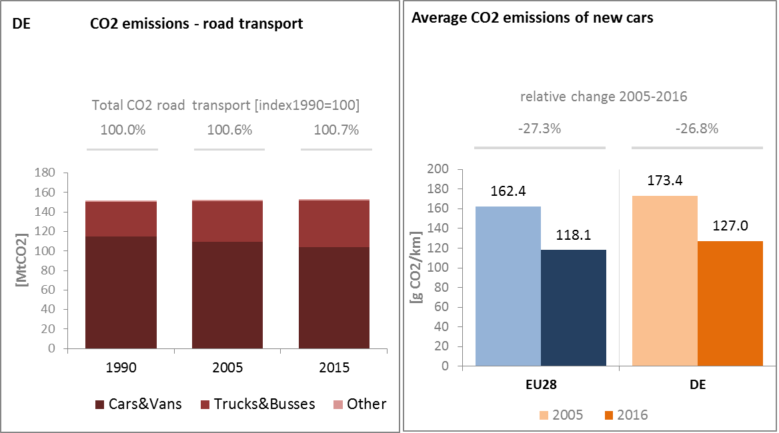

*(Source: European Environment Agency)*

The share of alternative fuel cars in total sales on the German market is marginal (i.e. below 1% in 2015); yet it increased slowly from 2013 onwards. In 2015, 0.74% of new cars in Germany were hybrid-electric and electric.

The number of electric charging points in Germany increased significantly from 2013 to 2016. The largest increase was observed between 2015 and 2016, when the number of charging points reached 17 953.

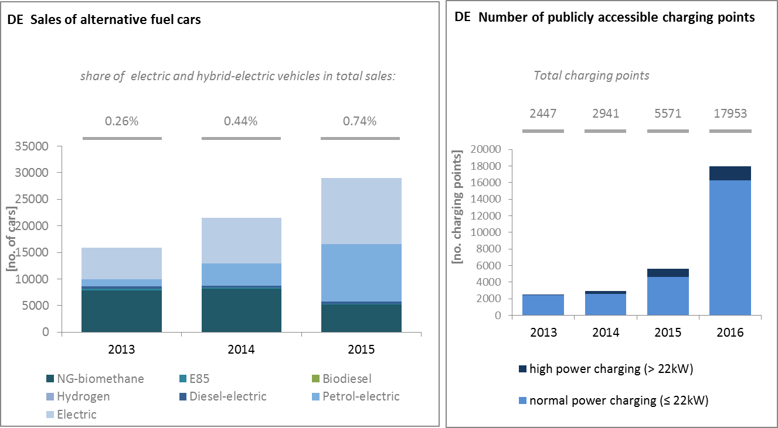

*(European Environment Agency) (European Alternative Fuels Observatory)*

National Policy Frameworks under Directive 2014/94/EU on alternative fuels infrastructure have to establish targets, objective and measures for the development of the market of alternative fuels in the transport sector and the deployment of the relevant infrastructure. Germany submitted its National Policy Framework as requested under article 3 of the Directive 2014/94/EU.

A detailed assessment of the German National Policy Framework in terms of its compliance with the requirements of Directive 2014/94/EU on alternative fuels infrastructure, its contribution to achievement of long-term energy and climate objectives of the Union and coherence of its targets and objectives in terms of cross-border continuity has been published as part of the Communication on Alternative Fuels Action Plans (COM(2017)652) and  the related staff working document SWD(2017)365.

* 1. **Adaptation to climate change**

Germany adopted its National Adaptation Strategy (Deutsche Anpassungsstrategie, DAS) in 2008, which presents an overview of effects of climate change, following a sectoral and a geographic approach respectively. The German Action Plan (Aktionsplan Anpassung der Deutschen Anpassungsstrategie, APA), operationalises the actions mentioned in DAS and was adopted in 2011. The APA follows a sectoral approach and identifies the following key sectors: human health, buildings, water regime, water management, coastal and marine protection, soil, biological diversity, agriculture, forestry and forest management, fishery, energy industry, financial services industry, transport and transport infrastructure, trade and industry, tourism. Progress on adaptation was reported for the first time in a Monitoring report in 2015 and is planned to be repeated every four years.

* 1. **Taxes on energy and transport and fossil fuel subsidies**

In Germany, the tax burden on energy and transport taxation amounts to 2.0% in 2014, nearly 0.4 p.p. lower than the average in the EU. This relative gap has increased since 2007, when it was 0.1 p.p. lower than the EU average. The tax burden on transport fuels has decreased since 2007, while the tax burden has remained broadly stable for heat and electricity as well as for vehicles. Germany has no CO2 component in the taxation of energy products, but the circulation tax for vehicles is partly based on CO2 emissions.

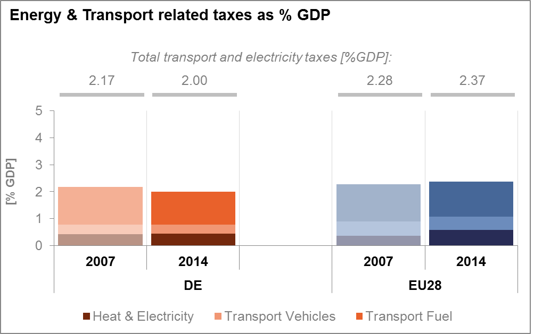

*(Source: Eurostat)*

Financial support for fossil fuels has been stable in Germany over the past decade. The most important measure was the government’s financial assistance to the uneconomic hard-coal industry for closing down its mines.

**

*(Source: OECD)*

* 1. **Renewable energy**

On renewable energy in general, Germany is on track in attaining its renewable energy target for 2020.

Germany was above the 2013/2014 and 2015/2016 indicative trajectory for RES share in gross final energy consumption; with a 14.6% share in 2015 Germany is still 3.4 p.p. below its 2020 target of 18% of final energy consumption set under the Renewable Energy Directive. Germany is (together with Spain) one of the largest contributors to onshore wind deployment in Europe; with several flagship projects. Regarding offshore wind, Germany was above the anticipated trajectory in 2015.

Germany's renewable energy share in transport was fluctuating over the years, not following a linear trajectory. The highest share of 7.5% was reached in 2007 and in 2011 respectively, decreasing to 6.8% in 2015 and thereby staying below the 10% target for 2020. Germany ranks among the main consumers of biodiesel and bioethanol in Europe.

The renewable energy share in Germany was 12.9% in 2015 the heating and cooling sector and about 31% in electricity generation.

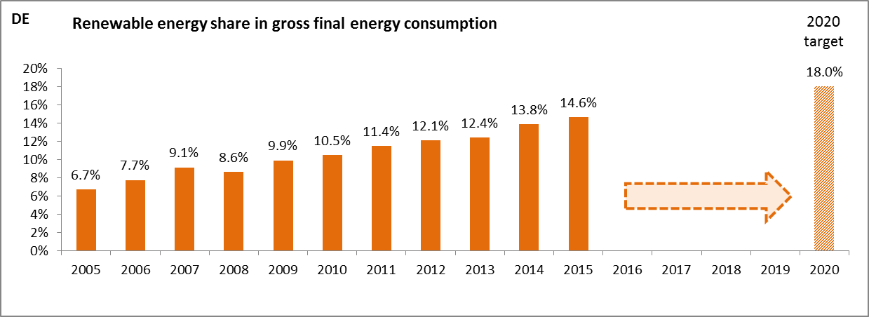

*(Source: Eurostat-SHARES)*

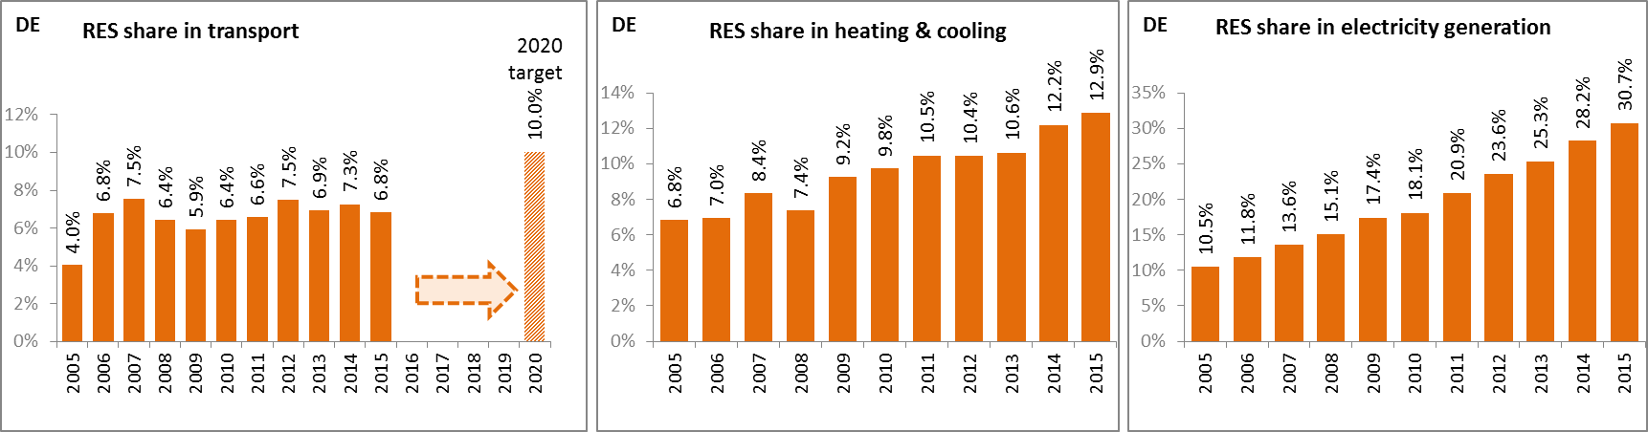

*(Source: Eurostat-SHARES)*

In Germany, electricity generation from renewable sources is supported by the renewable energy sources act (Erneuerbare Energien Gesetz, EEG 2017). Most generation capacities receive a (floating) market premium; in addition to the revenue generated at the electricity market. For most new installations, the award and the level of the market premium is determined through a tendering scheme. Small power plants up to 100 kW are exempted from the tendering process. They are still supported by a feed-in tariff. The criteria for eligibility and the tariff levels are set out in the renewable energy sources act.

A greenhouse gas (GHG) reduction quota (on fuel suppliers) is in place, which can be fulfilled, inter alia, through the use of biofuels.

Due to a consistent deployment of renewables since 2005, it is estimated that in 2015 Germany avoided about 11.7% of fossil fuel in gross inland consumption and about 11.9% of GHG emissions at national level[6].

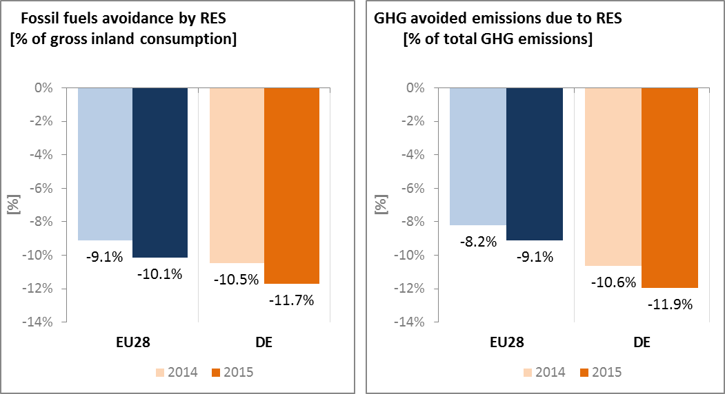

*(Source: EEA)*

* 1. **Contribution of the Energy Union to better air quality**

Air quality in Germany is a continuous cause for concern. For 2013, the EEA estimated that about 73 400 premature deaths were attributable to fine particulate matter (PM2.5) concentrations and over 10,610 attributable to nitrogen dioxide (NO2) concentrations[7].

For particulate matter (PM10) and NO2, Germany reported exceedances of the binding EU air quality standards[8]. For 2015, Germany reported exceedances of the limit value for PM10 in 3 out of 86 air quality zones, while exceedances of the limit value for NO2 were reported in 50 out of 89 zones[9].

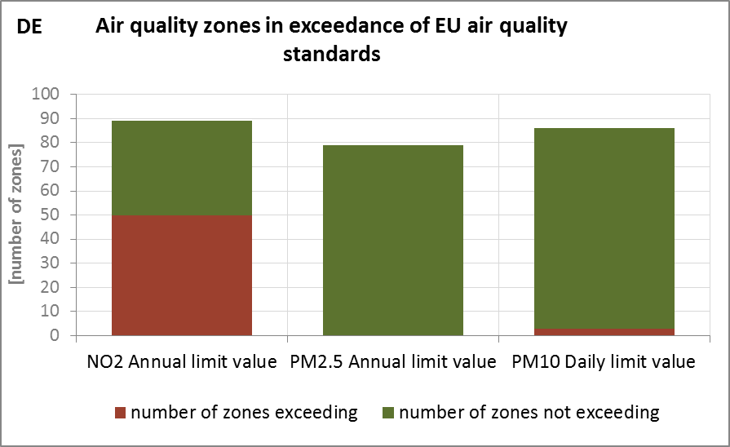

*(Source: EEA)*

The health-related external costs from air pollution in Germany have been estimated to be more than EUR 58 billion/year (income adjusted, 2010), which includes the intrinsic value of living a healthy life without premature death as well as the direct costs to the economy such as healthcare costs and lost working days due to sickness caused by air pollution[10].

The Energy Union can substantially contribute to address air quality problems through measures reducing emissions of both GHG and air pollutants such as PM and nitrogen oxides (NOx) from major contributing sectors such as (road) transport, energy production, industry and residential heating (e.g. stoves and boilers) as shown in the figure below[11].

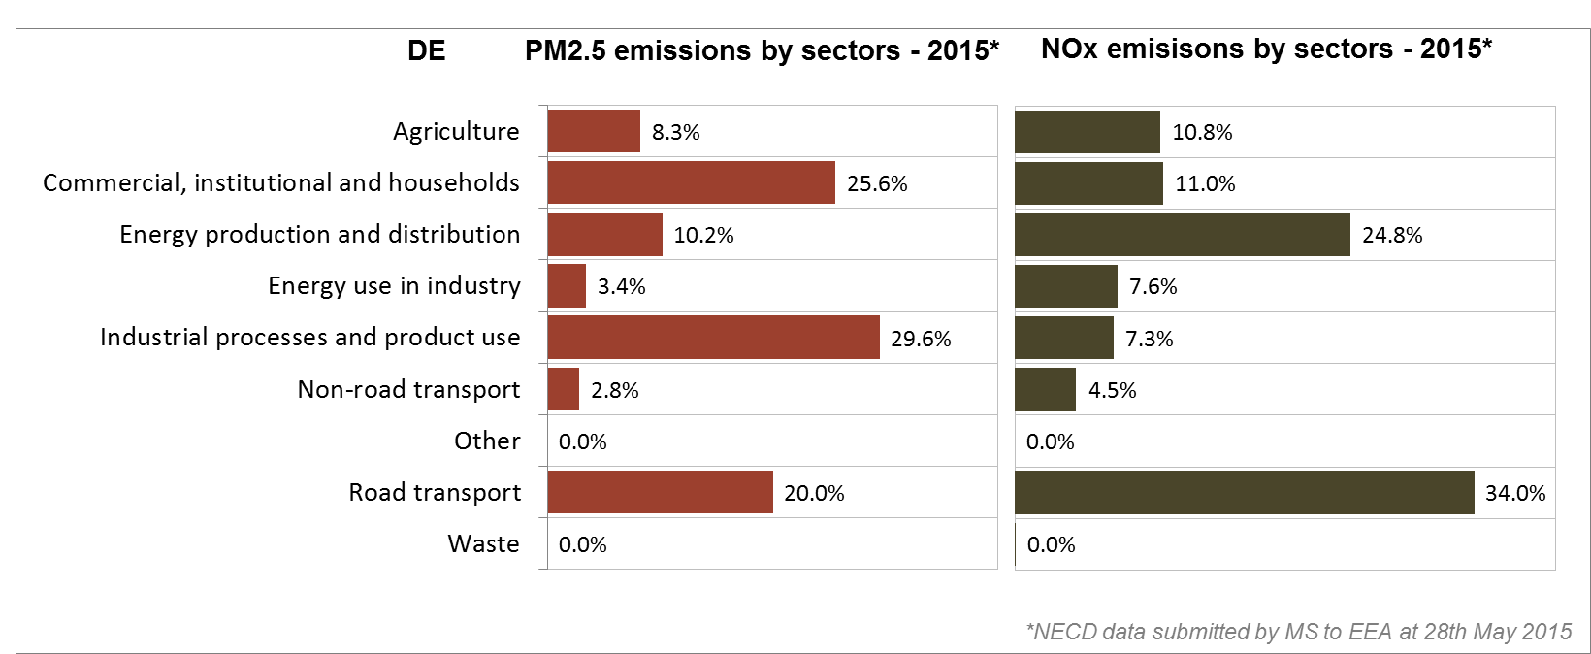

*(Source: EEA. This table reflects only sources of primary PM2,5 emissions.)*

**Research, innovation and competitiveness**

* 1. **Research and innovation policy**

The Federal Government has focused its funding for energy research and development on technologies supporting the low-carbon energy transition, particularly solutions in the areas of energy efficiency, energy conservation, renewable energy and supply systems (including storage, grids and ancillary system services through renewable energy as well as integrated energy approaches).

The 6th German Energy Research Programme builds on close cooperation of three Federal Ministries (Education and Research, Economic Affairs and Energy, and Food and Agriculture). Funding programmes focus on the two main pillars of the 6th Energy Research Programme: renewable energy technologies and energy efficiency. Areas of highest priority for research and innovation (R&I) within the field of renewable energy technologies are: (a) photovoltaics, (b) wind power, (c) storage technologies and (d) integration of power, heat and mobility sectors. Priority areas in the field of energy efficiency are (a) industry, trade and services and (b) buildings (a new funding initiative called 'Solar Buildings/Energy-Efficient Cities' has been initiated in this area).

In 2016, the Federal Ministry of Education and Research started the funding initiative 'Kopernikus Projects for the Energy Transition' to create a holistic R&I framework for the energy transition. The initiative has a duration of ten years. Large consortia consisting of 260 institutions from academia, industry and civil society organisations will work together on these projects to develop technological solutions for the transformation of the energy system. Kopernikus projects focus on four topics: Future grid structures, Power-to-X (to heat, transport fuels, and chemical base materials), Industrial processes and Energy systems integration.

Other recent flagship initiatives for energy R&I are the funding initiative 'Energiewende in the transport sector: sector coupling through the use of electricity-based fuels' (initiated in February 2017), the project 'Carbon2Chem' (focusing on the concept of carbon capture and utilisation), and the aforementioned 'Solar Construction/Energy-Efficient City' initiative. Furthermore, since 2014, research networks were funded in important subject areas with the objectives of promoting participation and transparency in energy research, acceleration of the transfer of results in practice, and quality assurance. These are currently being further developed and expanded.

Currently a new energy research program is in preparation. Central points are system optimisation, the use of synergies, digitalisation, sector coupling and an accelerated transfer of results to practice, e.g. through stronger inclusions of new actors like start-ups and strengthening the networking activities.

Germany is also an active contributor to the ongoing work of the Strategic Energy Technologies (SET) Plan. It participates in all the temporary working groups for the implementation of the integrated SET Plan, leading the one on photovoltaics and the one on energy efficiency in buildings/renewable heating and cooling. The German Federal Government also supports European research cooperation through additional bilateral commitments. Energy research is an important topic in this respect, and collaborations already exist with France, Finland, Switzerland, Austria and Greece.

Regarding the Horizon 2020 programme, Germany has so far received 17.2% of the EU contribution devoted to the 'secure, clean and efficient energy' part of the programme. As of September 2017, 555 participations from German organisations have been awarded EUR 312 million in Horizon 2020 energy projects. This includes a grant of EUR 12.5 million to Siemens for its participation in the project PROMOTION (offshore transmission networks), and four grants totalling almost EUR 23 million to German beneficiaries participating in project PACE (residential fuel cell combined heat and power installations).

Germany is a founding member of Mission Innovation[12]. As a result, it has committed to doubling its federal funding to clean energy R&I, from the baseline level of EUR 450 million to more than EUR 900 Million by 2020 for funding programmes which qualify under the objectives of Mission Innovation.

* 1. **Investments and patents in the Energy Union R&I priorities**

In 2016, public (national) investments in the Energy Union R&I priorities reached EUR 853 million having increased by 2% compared to 2015. This was also the highest annual public investment in the period 2007-2016. The largest share of investments (25%) was attracted by the Nuclear Safety R&I priority of the Energy Union, followed by the Renewables and the Smart System priorities (24% and 23% respectively). In 2014, the most recent year for which data for most Member States are available, public investment per GDP in Germany was similar to the EU average.

Private investment in the Energy Union R&I priorities in 2013, estimated at EUR 7 351 million, ranked the highest among the EU Member States (accounting for 46% of the private R&I investment in Energy Union R&I priorities in the EU). The focus was on Sustainable Transport (40%), followed by Efficient Systems (21%) and Renewables (20%).

In 2013, the most recent year for which complete patent[13] statistics are available, 752 companies and research organisations based in Germany filed 3 156 patents in low-carbon energy technologies. This is the highest among the EU Member States, accounting for 48% of the EU total. The focus was on Sustainable Transport (40%), followed by Efficient Systems and Renewables (21% each).

In 2013, both private R&I investments and patents in Energy Union R&I priorities were higher than the EU average when normalised by GDP and by population respectively. In the period 2007-2013 both private R&I investments and the number of patents in Energy Union R&I priorities increased on average by 5% and 14% per year, displaying lower rates of increase compared to the EU indicators (6% and 15% respectively).

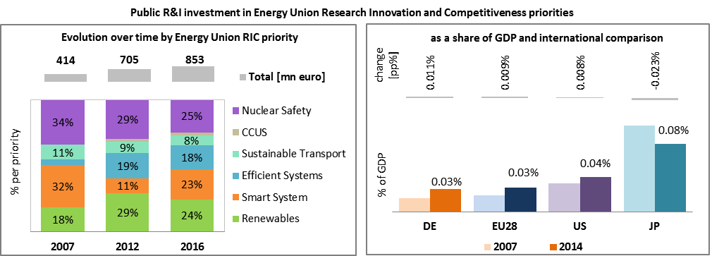

*Note: The international comparison (right) is shown for 2014 (Germany had reported EUR 799 million). Reporting at EU level for 2015 is not as complete, and very few countries have reported for 2016.*

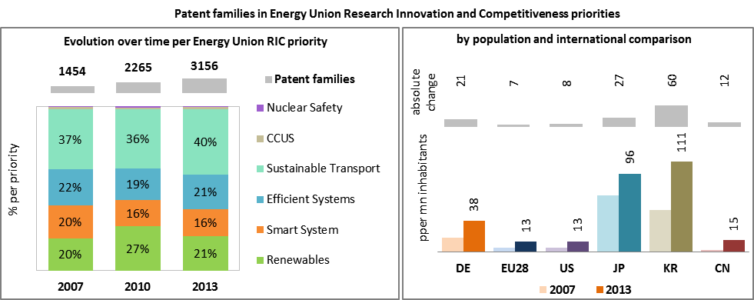

*(Data sources: Public investment as available in the International Energy Agency RD&D Statistics database[14] for codes relevant to Energy Union RIC priorities. Patent data based on the European Patent Office PATSTAT database[15]. Private investment as estimated by JRC SETIS. Detailed methodology available from the JRC[16].)*

* 1. **Competitiveness**

In 2014, the real unit energy costs (RUEC)[17] in Germany (12.2% of value added) were slightly below EU average (15.3% of value added), well below those in Japan and China but almost two times more than those in the United States of America. The electricity prices paid by industrial customers in Germany are above EU and OECD averages. Gas prices for industrial consumers are below the EU and OECD averages, leading to an increased industrial demand for gas in Germany.

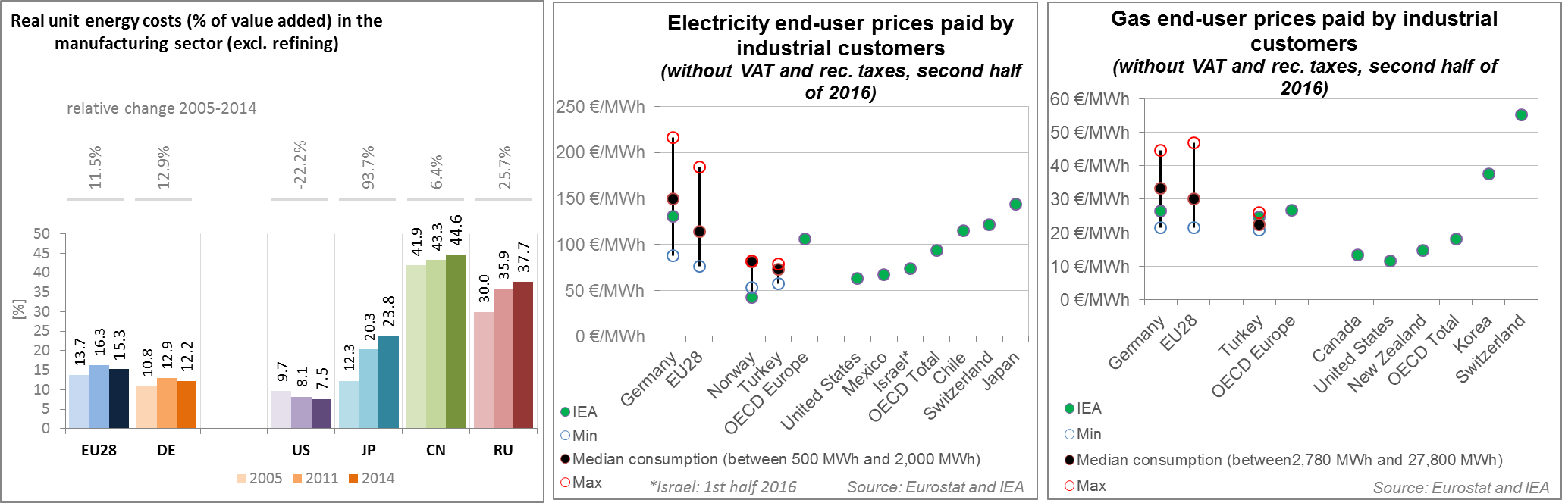

*(Source: ECFIN) (Source: Eurostat and IEA)*

Regarding the competitiveness of its wind and solar energy, Germany is performing very well in the wind sector due to a comparative advantage[18] in key components of the wind energy industry such as generating sets, gearboxes and power electronics. Germany is also performing well in the solar sector as indicated by the revealed comparative advantage indicator slightly above. This is due to a comparative advantage in the manufacturing of silicon and power electronics. The relative trade balance[19] confirms the strong position of Germany in the wind sector and Germany is a net exporter of wind components. However, Germany runs a trade deficit in the solar sector due to its trade deficit in solar photovoltaic modules and cells, yet it performs better than the EU average.

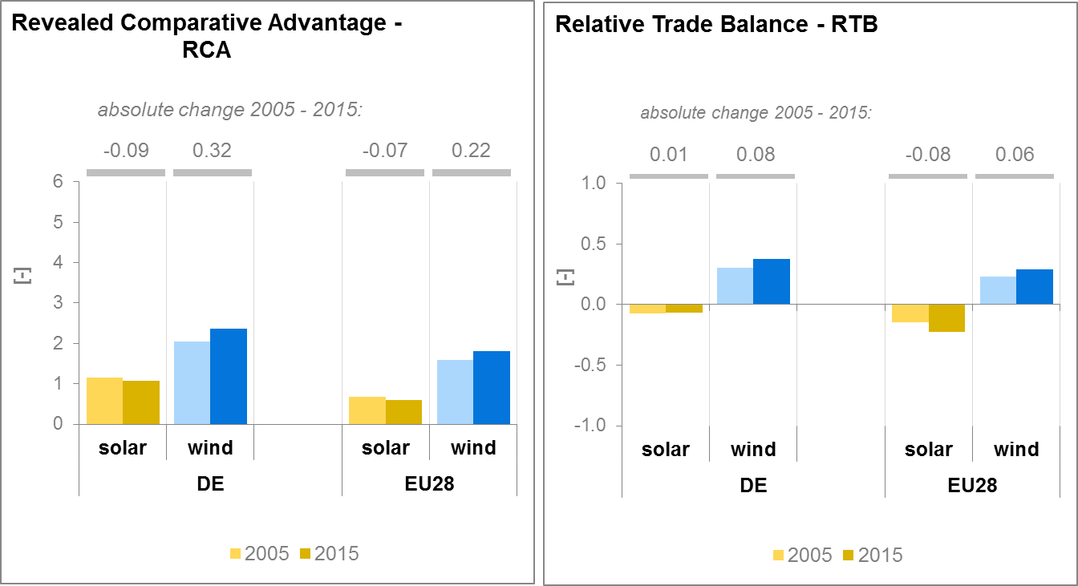

*(Source: UN comtrade)*

1. **Regional and local cooperation**

Germany is a member of the Pentalateral Energy Forum, created in 2005 by Energy Ministers of Benelux, Germany and France (with Switzerland as a permanent observer) in order to promote collaboration on cross-border exchange of electricity. Austria joined in 2011. The Pentalateral Energy Forum successfully implemented Flow-Based Market Coupling in 2015 on a voluntary basis, as first regional cooperation in Europe. Also in 2015, it published the first regional generation adequacy assessment in Europe. Inspired by that cooperation, the Pentalateral Gasplatform was established in 2009. The Gasplatform brings together the Benelux, Germany and France ministries responsible for gas market and security of supply.

Furthermore, Germany is part of the Baltic Energy Market Interconnection Plan (BEMIP), the first High-Level Group launched in 2009 by the Commission and Denmark, Sweden, Poland, Finland, Estonia, Latvia, Lithuania, Germany and Norway (observing status). BEMIP’s main objectives were to develop an internal and regional energy market between the EU Member States in the Baltic Sea region and integrating it fully into the EU's energy markets, thus increasing security of supplies. BEMIP projects have been part of the European Economic Recovery Plan (EERP) and the Trans-European Energy Networks Programme. BEMIP projects have also been funded through the EU's structural funds, including the European Regional Development Fund (ERDF) and the Cohesion Fund (CF). Many infrastructure projects are supported through CEF co-funding amounting to 534.3 million Euro. In the framework of the societal challenge for secure, clean and efficient energy of the Horizon 2020 programme, 16.9 million Euro is allocated to participants from the Baltics to stimulate research and innovation in this field.

Germany is also part of the Northern Seas High-Level Group, established through a political declaration with the participating countries (Belgium, Denmark, France, Germany, Ireland, Luxembourg, Netherlands, Sweden, the United Kingdom and EEA member Norway) and the European Commission on 6 June 2016.

Moreover, in July 2016, Denmark and Germany signed a cooperation agreement on the mutual opening of specific auctions for PV installations (joint action between Denmark and Germany). The agreement sets the framework for two pilot auction rounds to be held in Denmark and Germany in 2016 allowing for cross-border participation of installations for the first time. Moreover, the German cabinet adopted the recast of the cross-border renewable energy regulation (Grenzüberschreitende-Erneuerbaren-Energien Verordnung; GEEV). According to the recast regulation, 5% of new renewables capacity installed each year (ca. 300 megawatts) will be opened up to installations in other EU Member States in auctions.

In addition, Germany regularly organises meetings with its electricity neighbours to accompany and deliberate on the developments in the electricity sector. Electricity neighbours, i.e. states which have an electricity grid connection to Germany, are: Austria, Belgium, Czech Republic, Denmark, France, Luxembourg, the Netherlands, Norway, Poland, Sweden, and Switzerland.

The EU macro-regional strategies for the Baltic Sea Region, the Danube Region and the Alpine Region in which some of the German Länder take part can be used as a basis for regional cooperation on energy. European Territorial Cooperation – 'Interreg' – under EU cohesion policy also provides further opportunities for cross-border, transnational and interregional cooperation, including in the Energy Union areas.

Cities and urban areas have a key role in the energy and climate challenge. The Urban Agenda for the EU, established by the Pact of Amsterdam in May 2016, better involves cities in the design and implementation of policies, including those related to the Energy Union. It is implemented through Partnerships, in which the Commission, Member States, cities and stakeholders work together on a number of important areas, including on Energy Transition, Urban Mobility, Air Quality, Climate Adaptation and Housing. Germany is participating in the partnerships on Urban Mobility, with the city of Karlsruhe as co-coordinator, and Energy Transition, as member.

At the2016 edition of the Covenant of Mayors, the sustainable energy action plans delivered by 57 German municipalities had been assessed. Overall, the 57 municipalities cover approx. 15 million inhabitants representing ca. 18% of the total population in Germany. All together, these municipalities are committed to reducing GHG emissions by 34.1% until 2020 (as compared to 1990 baseline).

*Average GHG emission per capita in Covenant Baseline Emission Inventories and corresponding estimates by 2020 (Source: JRC)*

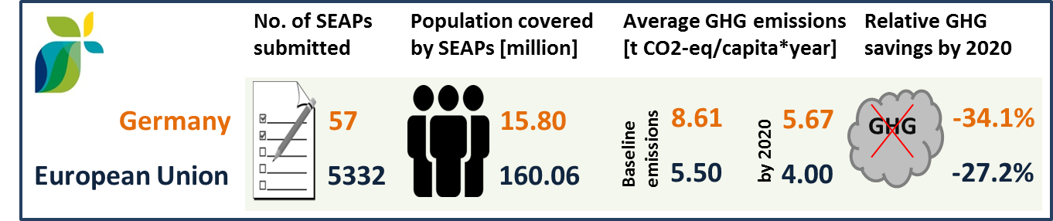

By September 2016, 15 German cities (covering 5.89 million inhabitants) have committed to conduct vulnerability and risk assessment and develop and implement adaptation plans in the framework of the Covenant of Mayors for Climate and Energy.

1. **Cohesion policy and EU clean energy investments**

EU cohesion policy makes a key contribution to delivering the Energy Union objectives on the ground, including investment possibilities to implement energy policy objectives in Germany which are complemented by national public and private co-financing, aiming at optimal leverage. It also ensures integrated territorial solutions to energy and climate challenges, supports capacity building and provides technical assistance.

Over 2014-2020, cohesion policy is investing some EUR 1,662 million in energy efficiency improvements in public buildings and in enterprises, as well as in high-efficiency cogeneration and district heating, renewable energy and innovative pilot projects on smart electricity distribution grids in Germany. Cohesion policy is also investing significantly in R&I and in SME competitiveness in Germany, based on the regional strategies for smart specialisation. For Germany, many strategies include a focus on low-carbon technologies. At this stage, at least EUR 251 million is foreseen for investments in R&I and adoption of low-carbon technologies in Germany, but this might increase further in line with the evolving content of the smart specialisation strategies. A further estimated EUR 555 million is invested in supporting the move towards an energy-efficient, decarbonised transport sector.

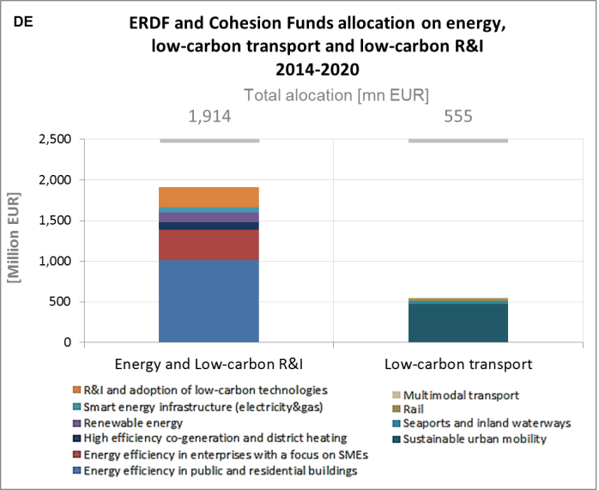

*(Source: DG REGIO)*

These investments are expected to contribute to a decrease of around 230,000,000 kWh per year of primary energy consumption of public buildings, as well as around 100 MW of additional capacity of renewable energy production and 1,000 additional users connected to smart grids. Overall, the EU cohesion policy investments in Germany over 2014-2020 are expected to contribute to an estimated annual decrease of GHG emissions of around 2,200,000 tonnes of CO2eq.

For example, with the aim of being independent of developments in the volatile gas market while providing citizens with secure energy to enhance the quality of life, the municipal energy supplier in the city of Schwerin started, at the end of November 2015, one of the biggest geothermic projects in Mecklenburg-West Pomerania, using existing thermic brine for distant heating. The project will help the city to fulfil its goal to become CO2-neutral by 2050. The contribution from the European Regional Development Fund (ERDF) amounts to EUR 9.2 million.

As another example, the project on technology transfer on innovative energy technologies and energy efficiency for SMEs in Ulm started in autumn 2014 and aims at bringing closer science and SMEs. Through the core competence of innovative energy technologies, the science city Ulm makes an important contribution to improve energy efficiency and sustainable energy production and consumption. The contribution from the European Regional Development Fund (ERDF) amounts to EUR 184,258.

Through its support to sustainable transport systems, the Connecting Europe Facility (CEF) also contributes to the goals of the Energy Union. Following German participation in the CEF – Transport 2014–2015 Calls, the German action portfolio comprises 65 signed grant agreements, allocating EUR 1,923.8 million of actual CEF Transport Funding to German beneficiaries (state-of-play February 2017)[20]. The transport mode which receives the highest share of funding is rail (85.5% of actual funding). The German rail actions focus on connecting maritime ports to the rail network, addressing both national and cross-border rail bottlenecks, and the deployment and implementation of the European Rail Traffic Management System (ERTMS). In addition, investments in multimodal logistic platforms focus at the enhancement of the railway connections in ports. At the same time, actions within the freight transport services priority aim at increasing the market share of railway in sectors where just-in-time logistics is required.

Another large share of the German portfolio corresponds to air actions, where Germany is involved in both mono-beneficiary and multi-beneficiary actions covering both studies and works. All the multi-beneficiary actions contribute to deploying The Single European Sky ATM Research (SESAR) Pilot Common Projects. The mono-beneficiary actions include the deployment of Remote Tower Control (RTC) concepts in Germany, as well as new radar technologies, with the scope of improving performance, interoperability and modernisation. Germany is also participating in a very large and ambitious Inland waterway (IWW) action, River Information Services Corridor Management (COMEX), in which 13 countries have joint forces to improve cross-border cooperation with a view to achieving a service for navigation corridors. In the field of innovation in the area of IWW, German beneficiaries have been involved in actions related to a pilot deployment of LNG fuelled vessels and a pilot implementation of shore-side LNG stations.[21]

1. The indicators used in this country factsheet largely build on indicators developed for the Commission Staff Working Document "Monitoring progress towards the Energy Union objectives – key indicators" (SWD(2017) 32 final) <https://ec.europa.eu/commission/sites/beta-political/files/swd-energy-union-key-indicators_en.pdf>
2. Gross value added and employment in NACE sectors D-Electricity, gas, steam and air conditioning supply and H-Transportation and storage
3. National accounts, Eurostat
4. Gross fixed capital formation consists of resident producers´ acquisitions, less disposals, of fixed tangible or intangible assets. This covers, in particular, machinery and equipment, vehicles, dwellings and other buildings. It also includes foreign direct investment (FDI). Steam and air conditioning supply are also included in the figures mentioned above as Eurostat reports electricity, gas, steam and air conditioning supply together.
5. The interconnectivity level is calculated as a ratio between import interconnection and net generation capacities of the country (i.e. the 2017 value is the ratio between simultaneous import interconnection capacity [GW] and net generating capacity [GW] in the country at 11 January 2017, 19:00 pm as resulted from ENTSO-E Winter Outlook 2016/2017)
6. Avoided GHG emissions mentioned here have a theoretical character as these contributions do not necessarily represent 'net GHG savings per se' nor are they based on life-cycle assessment or full carbon accounting.
7. European Environment Agency, 2016, [Air Quality in Europe – 2016 Report](https://www.eea.europa.eu/publications/air-quality-in-europe-2016), table 10.2. The report also includes details as regards the underpinning methodology for calculating premature deaths.
8. Directive 2008/50/EC of the European Parliament and of the Council of 21 May 2008 on ambient air quality and cleaner air for Europe, OJ L 152, 11.6.2008, p.1-44
9. Compliance data as reported by the Member States as part of their official annual air quality report for the calender year 2015 (available on the European Environment Agency's (EEA) Eionet/Central Data Repository), <http://cdr.eionet.europa.eu/de/eu/aqd>
10. See also the EU Environmental Implementation Review Country Report for Germany, SWD(2017)38 final of 3.2.2017
11. National emission data as reported by the Member States to the EEA (available on the EEA's Eionet/Central Data Repository), <http://cdr.eionet.europa.eu/de/eu/nec_revised>
12. <http://mission-innovation.net/>
13. In the context of this document, the term 'patent' refers to patent families, rather than applications, as a measure of innovative activity. Patent families include all documents relevant to a distinct invention (e.g. applications to multiple authorities), thus preventing multiple counting. A fraction of the family is allocated to each applicant and relevant technology.
14. <http://www.iea.org/statistics/RDDonlinedataservice/>
15. <https://www.epo.org/searching-for-patents/business/patstat.html#tab1>
16. <https://setis.ec.europa.eu/related-jrc-activities/jrc-setis-reports/monitoring-ri-low-carbon-energy-technologies>
17. This indicator measures the amount of money spent on energy sources needed to obtain one unit of value added.
18. The RCA index for product "i" is defined as follows: ${RCA}_{i}=\frac{\frac{X_{j,i}}{\sum_{i}{X_{j,i}}}}{\frac{X_{w,i}}{\sum_{i}{X_{w,i}}}}$ where $X$ is the value of exports, and j is the country and w is the reference group, the World economy. 2005 refers in the text to the indicator average over the 2000-2009 period, while 2015 represents the average over the 2010-2016 period. The same applies for the RTB indicator - see below.
19. The RTB indicator for product "i" is defined as follows: ${RTB}_{i}=\frac{X_{i}-M_{i}}{X_{i}+M_{i}}$ where $X_{i}$ is the value of product's "i" exports and $M_{i}$ imports.
20. Note that European Economic Interest Groups and International Organisations are excluded from the analysis.
21. Source: INEA